College of Agricultural and Environmental Sciences
Department of Crop and Soil Sciences

MEMORANDUM TO: Soybean Seedsmen
FROM: Daniel J. Mailhot
DATE: January 30, 2024
SUBJECT: Georgia 2024 Soybean Performance Trials

Instructions for submitting entries into the Soybean Performance Trials are outlined below.

General Information – All varieties of a maturity group are tested together regardless of their commercial status or herbicide traits. The MG 4 and MG 5 tests require glyphosate tolerance, while the MG 6 and MG 7 tests utilize a conventional herbicide management program. A variety may be entered into more than one maturity group test if desired. However, we cannot harvest your variety earlier or later than others in the test. This could result in shattering or a lack of harvestable plots at some locations.

Seed Treatment – Commercial seed treatments may be utilized, and fungicidal, insecticidal and nematicidal components are acceptable. The seed treatments used will be disclosed to readers. Please ensure seed is properly labeled.

Testing Options –
Maturity Group 4 – Tests will be conducted at Tifton, Griffin, and Rome (2 plantings) for a total of 4 environments. Plantings are targeted for mid-April. Chemical defoliation will be utilized, and glyphosate tolerance is required.
Maturity Group 5 – Tests will be conducted at Attapulgus, Tifton, Midville, Plains,
Griffin (2 plantings), Athens, and Rome for a total of 8 environments. Plantings are targeted from late April through mid-May. Glyphosate tolerance is required. Those lacking tolerance should be placed in the MG 6 test.
Maturity Groups 6 and 7+8 – Tests will be conducted at Tifton, Midville, Plains (2
plantings), Griffin (2 plantings), and Athens (8 total environments), , and planted in May. All herbicide trait options including conventional are accepted, and a conventional herbicide program will be utilized. Only private companies will be assessed the fee of $1,000 per entry (8 testing environments).
RKN and Soybean cyst nematode screening – This free greenhouse-based test is provided
by UGA nematologists. Unless you notify us otherwise, we will include all your
submitted entries.
Ultra-late planting – Selections for this test will be made by the SWVT program director
based on prior ultra-late performance, availability to farmers in 2025, and plant height. Previously-tested varieties with lower yields will not be re-evaluated.

Testing Fees – The fee for the Georgia Soybean Performance Trials is $500 per entry for Maturity Group 4 tests, and $1,000 per entry for Maturity Groups 5, 6, and 7/8. The fee is $500 per entry for maturity group 4. Invoices will be sent from Griffin campus. No refund will be issued in the event that a test is lost due to weather or other circumstances beyond the reasonable control of OVT.

Deadlines – Applications are due February 23, 2024. Please send seed as soon as possible,
preferably no later than March 15th.

Seed Required – The application will calculate the required number of seeds based on the tests you enter. If you are using a paper copy, or are unsure of your seed size, sending 20 pounds of a variety per maturity test entered should be adequate.

Shipping Instructions – Please choose the address based on your preferred shipper.

FedEx or UPS (Preferred): US Postal Service:
Daniel Mailhot Daniel Mailhot
UGA-Variety Testing UGA-Redding Building
1655 GA 16 West 1109 Experiment Street
Griffin, GA 30223-2091 Griffin, GA 30223-1731

If you have any questions or for some reason cannot send the seed by the specified date, please contact Statewide Variety Testing at 678-572-3015 or by e-mail to daniel.mailhot@uga.edu. Thank you for your cooperation.

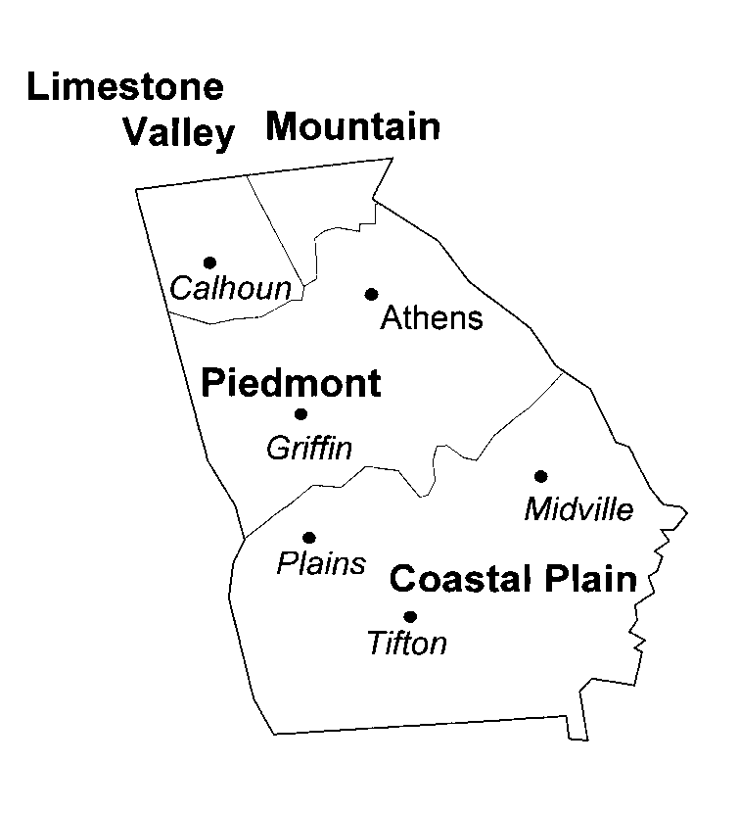
Results from the 2023 performance tests of agronomic crops in Georgia are available at our website www.swvt.uga.edu..

TEST LOCATIONS

. Attapulgus
.

College of Agricultural and Environmental Sciences
Department of Crop and Soil Sciences

GUIDELINES FOR THE GEORGIA
STATEWIDE SOYBEAN PERFORMANCE TRIALS

1. A fee will be assessed for each entry submitted by private companies for evaluation in each test. An invoice will be sent. Payment is due 30 days from the invoice date.

2. Entries submitted by public agencies, such as public universities or USDA, will not be charged a fee for inclusion in the trial(s).

3. Entry fees for tests lost due to weather or other circumstances beyond the reasonable control of OVT will not be refunded.

4. Do not submit any seed containing regulated or stewarded biotechnology traits.

5. Seed produced from the trials, as well as any excess planting seed, will be destroyed and/or combined with other entries’ seed and disposed of as commodity grain.

6. Participants retain full rights to their intellectual property. Please send any desired Material Transfer Agreements (MTA’s) to UGA Innovation Gateway Contracts Manager (igcontracts@uga.edu.) MTA’s are only valid if signed by an authorized representative of the UGA Research Foundation, Inc. Please allow adequate lead time if your application involves a MTA for submission of entries.

7. Results will be published in an annual report. Individual plot data is not provided to participants.

8. The Program Director, in concert with the Department Head, reserves the right to close a test due to a lack of entries or to limit the number of entries in any given test.

